Raptor Nest Search Form

Coupe No.: Grid Coordinates: ………..……mE ……………mN (GDA)

Action | Person | Date | Result
Previously searched?
Potential nesting habitat assessment |  |  | Potential nesting habitat area (attach map)
Search of nesting habitat | Person-hours: |  | Search results (mark area searched on map as part of biodiversity evaluation and provide FPA with digital shape files of search area for monitoring purposes)
Follow-up search(?) | Person-hours:
Notification to FPA
Nest site added to NVA
Reserve added to planning maps/GIS

Raptor Nest Location Form
Nest number and name (Office use only):

SPECIES:
OBSERVER: name, address, phone/fax

DATE OF THIS REPORT: | WHEN WAS THE NEST FOUND?

HOW WAS THE NEST FOUND? eg. during pre-logging search, during forestry operation, etc.

HAD THE AREA BEEN PREVIOUSLY SEARCHED? give detail

LOCATION OF NEST:
Nearest feature: …………………….…………………………………………………………………………………………..
FPP number: …………………………..… Coupe number: ………………………………………………Grid
Coordinates: ………………………….....E ………………………………..N Mapsheet: …….……….…………Datum (GDA/AGD): ……………… GPSed? YES / NO Accuracy (m) …………
NEST SITUATION: was it in a tree (species?), on a cliff, or on the ground?

HISTORY OF NEST USE: known breeding attempts? results?

NEST DISTURBANCE: forestry, recreation, roading, building, etc.?

WHAT WAS SEEN? eggs, birds, droppings, nest material, prey, etc.?

Raptor Nest Activity Assessment Form
Specialist Use Only
Activity Classification
Active
Not in use
Requires Confirmation

- Ground assessments are NOT to be conducted on days when the temperatures are extreme (<10⁰C or >30⁰C) or raining.
- Time within 100m of the nest not to exceed 20 minutes.
- Time within 200m of the nest not to exceed 1 hour.
Nest Number: |  |  |  |  |  | Date:
Observer Name and Contact Details: |  |  |  |  | Location Name:
Environmental Variables  Estimated Temperature: ……………..  Fine / Overcast / Showers (Please circle)  Notes: |  |  |  |  | Grid Reference of Nest  Datum (circle): GDA AGD  Easting ……………………………….……….. (6)  Northing ……………….……………………….. (7)  Co-ordinates where you observed nest  Easting ……………………………….……….. (6)  Northing ……………….……………………….. (7)
Start Time: (hh:mm)  : |  | Finish Time: (hh:mm)  : |  |  |  |  |  | Duration (mins):
Nest Description: (Provide any further comments relating to what was observed)  Tick if the nest has no vantage points or you believe nest cannot be accurately assessed. Tick Here  Make sure all boxes have been marked |  |  |  | Were any of these observed on the nest? (Each box MUST be marked Yes/No or Not Assessed )
 |  |  |  | Green leaves
 |  |  |  | Fresh (brown) sticks
 |  |  |  | White wash (droppings)
 |  |  |  | Flat compressed nest top
 |  |  |  | Nest Bowl (concave nest platform)
 |  |  |  | Brown leaves on nest
 |  |  |  | Down on/around nest
 |  |  |  | Nest partly/mostly bleached
 |  |  |  | Nest condition Poor/average/good/excellent
 |  |  |  | Prey remains
 |  |  |  | Bird on nest or nearby (note age if possible)
Bird Activity Observed: (Describe what was observed e.g. Two birds soaring over the nest, bird carrying sticks)
Note: Be specific in your description. Comments such as “nest untidy” (common to all nests) provide little detail

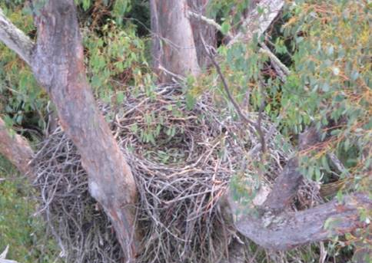
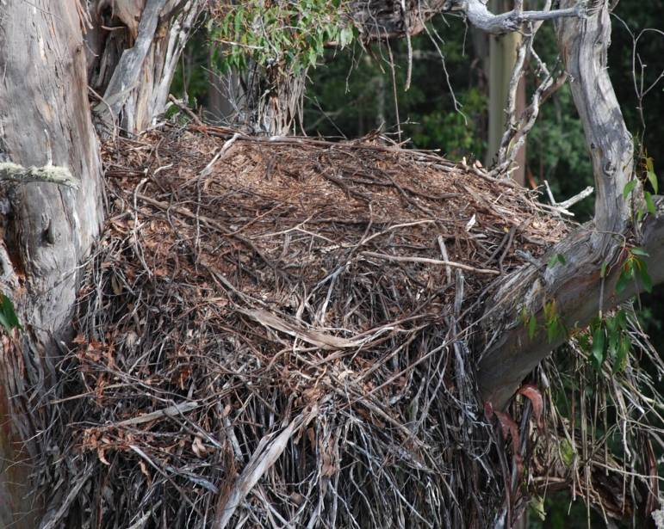
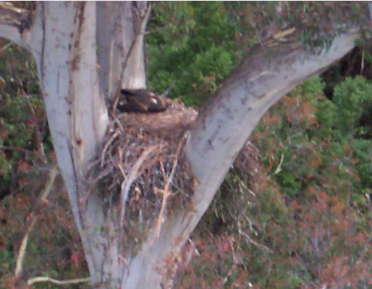
Appendix 2. Nest attributes to consider during activity assessments
Nest with compressed flat top
(Flat from chick moving on top from past year)
Nest bowl
(Dished surface. Evident by chick sitting low in nest)

Brown leaves and whitewash
(Obvious addition of leaves and whitewash)
Nest has no vantage point
(This nest cannot be assessed accurately)
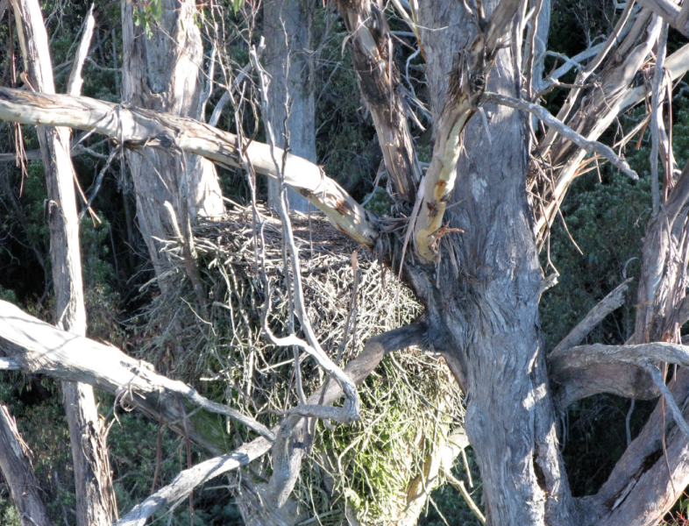
Nest partly or mostly bleached
(No brown sticks, green leaching present)
Recently added green leaves
(Recent addition of leaves and some whitewash)

