Raptor Nest Activity Check Form (ground-based only)

THIS FORM IS FOR USE BETWEEN MID-OCTOBER AND THE END OF DECEMBER ONLY.
- Ground based nest activity checks are discouraged and can only be undertaken under exceptional circumstances following consultation with FPA.
- A maximum of two accredited people are to undertake the activity check. The wearing of hi-vis equipment during the check may result in raptors flushing the nest and leaving eggs, or chicks exposed.
- Ground checks must not to be conducted on days when the temperatures are extreme (<10°C or >30°C) or when it is raining.
- On days when there is suitable weather to undertake an activity check:
- Plan to conduct the inspection upslope of the nest to provide the best possibility of observing the nest surface and any associated nest contents.
Specialist Use Only
Activity Classification
Active
Not in use
Requires Confirmation
- Only approach the nest as closely as you need to make the observations, but do not approach closer than 100 m of the nest site.
- No more than 20 minutes is to be spent between 100 m to 200m of a nest to assess if the nest is active and record observations.
- Noise during the conduct of the inspection must be kept to an absolute minimum, there should be no need for any significant noise, especially loud talking etc.
- If a bird is observed on the nest or in the immediate area, including circling overhead, leave the nest vicinity immediately (i.e. move at least 500 m away from the nest).
Nest Number: |  |  |  |  | Date of check:
Observer Name(s) and Contact Details: |  |  |  |  | Location Name:
Environmental Variables  Estimated Temperature: ……………..  Fine / Overcast / Showers (Please circle)  Notes: |  |  |  |  | Grid Reference of Nest  Easting ……………………………….……….. (6)  Northing ……………….……………………….. (7)  Co-ordinates where you observed nest  Easting ……………………………….……….. (6)  Northing ……………….……………………….. (7)
Time from leaving vehicle to observation point 200m from nest (hh:mm):  : |  |  | Duration of observation of nest: |  |  |  | Time leaving observation point (hh:mm)  :
Were any of these observed on the nest? (Each box MUST be marked Yes/No or Not Assessed)
Green leaves |  |  |  | Nest partly/mostly bleached
Fresh (brown) sticks |  |  |  | Nest condition (circle) poor average good excellent
White wash (droppings) |  |  |  | Prey remains
Flat compressed nest top |  |  |  | Eagle nearby nest (note age if possible)
Nest Bowl (concave nest platform) |  |  |  | Egg on nest
Brown leaves on nest |  |  |  | Chick on nest
Down on/around nest |  |  |  | Adult eagle in incubating position on nest
Nest Description: (Provide any further comments relating to what was observed):
Bird Activity Observed: (Describe what was observed e.g. Two birds soaring over the nest, bird carrying sticks)
Note: Be specific in your description. Comments such as “nest untidy” (common to all nests) provide little detail

Tick box if the nest has no vantage points or you believe nest cannot be accurately assessed.

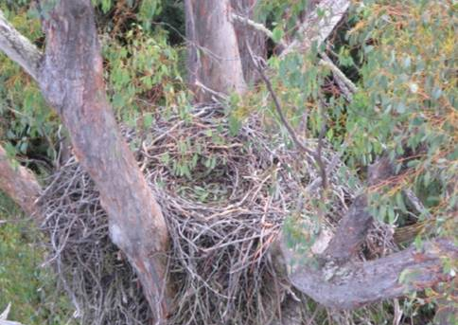
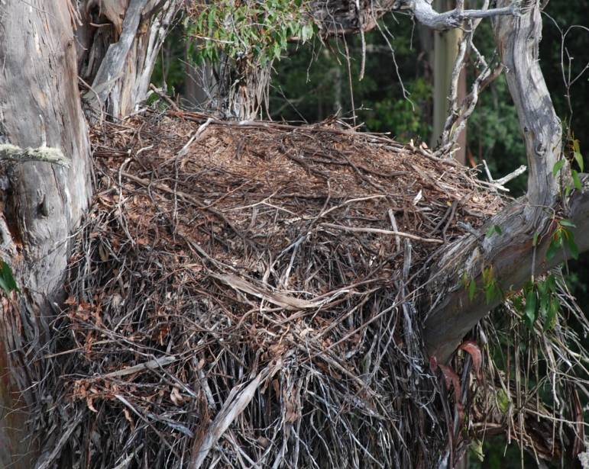
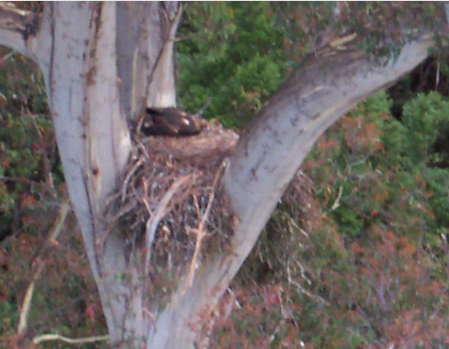
Appendix 1. Nest attributes to consider during nest condition assessments
Nest with compressed flat top
(Flat from chick moving on top from past year)
Nest bowl
(Dished surface. Evident by chick sitting low in nest)

Brown leaves and whitewash
(Obvious addition of leaves and whitewash)
Nest has no vantage point
(This nest cannot be assessed accurately)
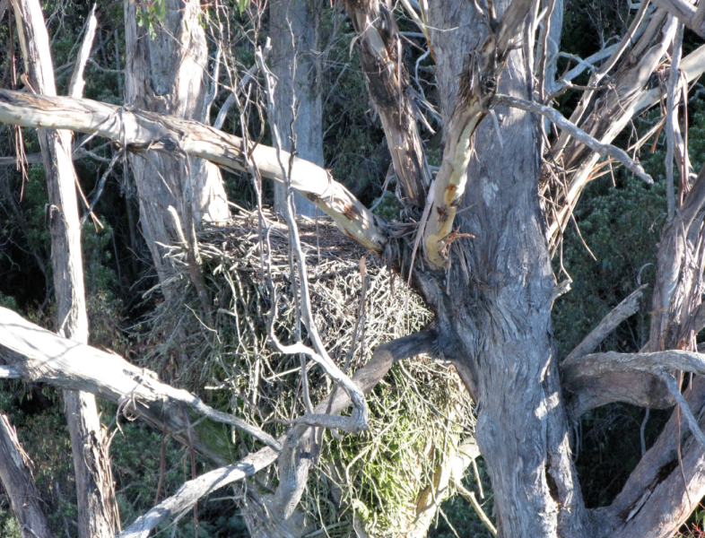
Nest partly or mostly bleached
(No brown sticks, green leaching present)
Recently added green leaves
(Recent addition of leaves and some whitewash)

