Raptor Nest Condition Assessment Form

THIS FORM IS FOR USE OUTSIDE OF THE EAGLE MANAGEMENT CONSTRAINT PERIOD ONLY.
- This form is only to be used for nest condition assessments and not for nest activity checks. For nest activity checks use the FPA’s Raptor Nest Activity Check Form.
- Nest condition assessments can be undertaken from the ground or using Unmanned Aerial Vehicles (UAV) or using a rotor-wing aircraft (helicopter).
- When using UAV (drones) to conduct nest condition assessments flights must only be conducted between April and June.
- This form can be submitted via the Raptor Notifications Database as supplementary information for advice requests.
Nest Number: |  | Date:
Observer Name(s) and Contact Details:  Pilot name (if using UAV) and Contact Details: |  | Nest Location Name:
Grid Reference of Nest (from database):

Easting:.…………………….………….….………….………. (6) | Northing:……………….………………………………………… (7)
Were any of these observed on the nest? (Each box MUST be marked Yes/No or Not Assessed)
Green leaves |  |  | Nest partly/mostly bleached
Fresh (brown) sticks |  |  | Down on/around nest
White wash (droppings) |  |  | Nest partly/mostly bleached
Flat compressed nest top |  |  | Nest condition (circle) poor average good excellent
Nest Bowl (concave nest platform) |  |  | Prey remains
Brown leaves on nest |  |  | Eagle nearby nest (note age if possible)
Down on/around nest |  |  | Old egg on or egg fragments nest
Nest Description: (Provide any further comments relating to what was observed)

Bird Activity Observed: (Describe what was observed e.g. Two birds soaring over the nest, bird carrying sticks)
Note: Be specific in your description. Comments such as “nest untidy” (common to all nests) provide little detail

Tick box if the nest has no vantage points or you believe nest cannot be accurately assessed.
Will you submit this data to the Natural Values Atlas? (circle). If NO, the FPA will submit this information to the NVA. |  |  |  | YES
 |  |  |  | NO

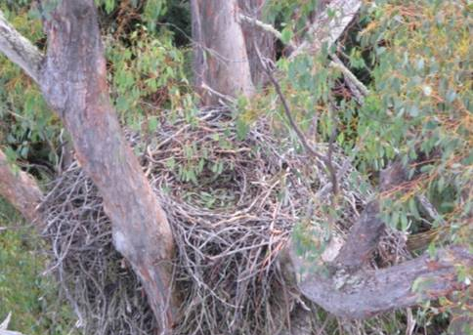
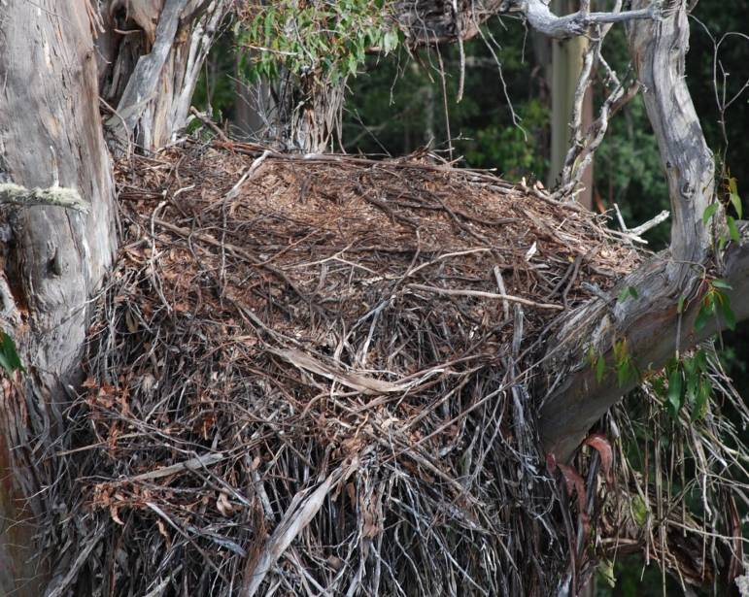
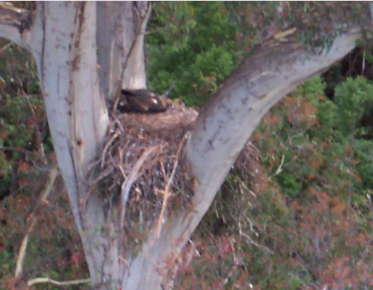
Appendix 1. Nest attributes to consider during nest condition assessments
Nest with compressed flat top
(Flat from chick moving on top from past year)
Nest bowl
(Dished surface. Evident by chick sitting low in nest)

Brown leaves and whitewash
(Obvious addition of leaves and whitewash)
Nest has no vantage point
(This nest cannot be assessed accurately)
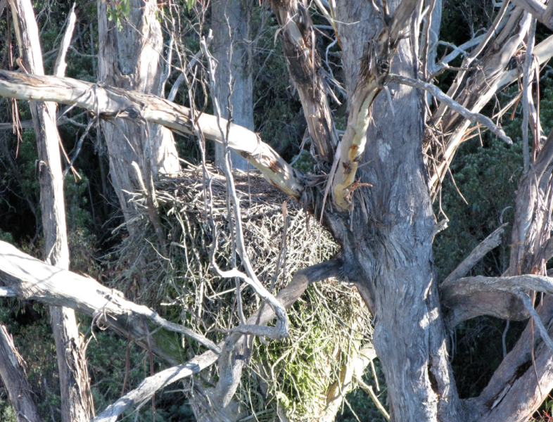
Nest partly or mostly bleached
(No brown sticks, green leaching present)
Recently added green leaves
(Recent addition of leaves and some whitewash)

